NAME:Rishik JK
REG.NO :192511052

CSA1702-ARTIFICIAL INTELLIGENCE
LAB EXPERIMENT

28. Prolog Program for Medical Diagnosis

1. Aim
To write a Prolog program to identify a possible disease based on the symptoms provided by the patient.

2. Algorithm
- Start the program.
- Define facts for symptoms associated with diseases.
- Define rules to identify diseases based on symptoms.
- Enter the patient's symptoms as a query.
- Check the symptoms against the database.
- Display the possible disease.
- Stop.

6. Result
Thus, the Prolog program for medical diagnosis based on symptoms was successfully implemented and executed.
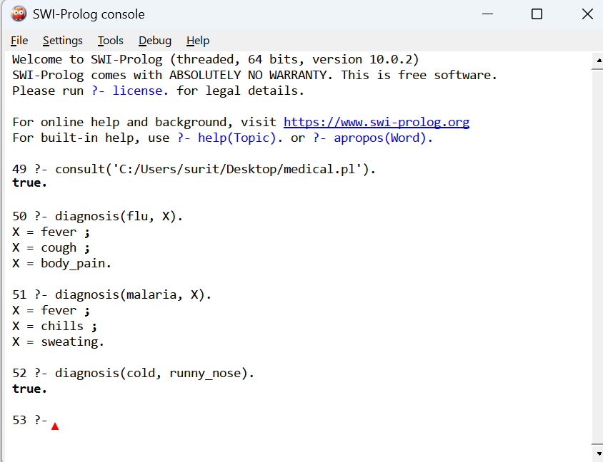

3. Result
Thus, the Prolog program for medical diagnosis based on symptoms was successfully implemented and executed.

